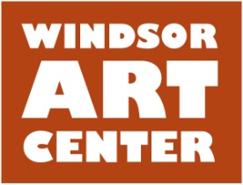

**Press Release** **Contact**: Susan Kiss

Immediate 860-429-8071

March 26, 2016

**Call to Artists: Second Annual Members Exhibition**

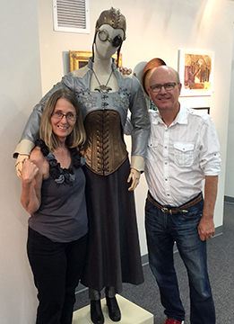

WINDSOR, CT - The Windsor Art Center invites all current members to submit work to the Second Annual Members’ Exhibition, which will be on view May 14 – June 25, 2016. Members may submit up to 2 works of art that are properly prepared for exhibition. Sculptures require their own base/pedestal. Patricia Hickson (Emily Hall Tremaine Curator of Contemporary Art, Wadsworth Atheneum Museum of Art, Hartford, CT) has graciously accepted our invitation to act as this year’s Juror of Award. A Best in Show Cash Prize will be awarded at the Opening.

Members are encouraged to attend a **free workshop** “Preparing and Presenting Art for Gallery Exhibition” on Saturday, April 16, 1:30-3:30PM. Presented by curatorial committee members Susan Kiss, and Roberta Contois, the workshop will cover such topics as matting and framing, the various tools and supplies needed to mat and frame your own work and where to obtain the supplies needed. Please bring any questions you may have. The workshop is free for current members. The fee for non-members is $10.00.

For a full description of eligibility and submission requirements or to become a member please go to [www.windsorartcenter.org](http://www.windsorartcenter.org)

Located in Windsor, Connecticut, the Windsor Art Center is a nonprofit organization that promotes the visual and performing arts and presents visual art exhibits showcasing the works of a variety of artists working in diverse media and genres and hailing from throughout New England and beyond. Artist “talks” and children’s activities complete the annual programming. There is no charge to visit the gallery or the on-site gift shop which features locally made art. Parking is free and easily accessible. For more information on scheduled programs and exhibits, membership, and performing or exhibiting in the gallery, visit [www.windsorartcenter.org](http://www.windsorartcenter.org).