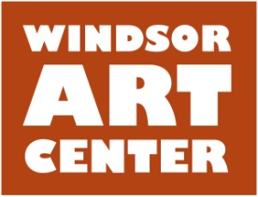

**Press Release** **Contact**: Susan Kiss

Immediate 860-249-8071

April 24, 2016

**Join Us for**

**“Art on Both Sides of the Track”**

WINDSOR, CT - The Windsor Art Center *and* Studios invite you to join us on Saturday, May 14 for

“Art on Both Sides of the Track”, starting at 5:00PM. Both Windsor Art Center buildings will be open for your pleasure. The Juried Members’ Exhibition Opening Reception takes place from 5:00-7:00PM at the Art Center. Sample the hors d’oeuvres and witness the presentation of the Best in Show Award. Across the tracks, enjoy more Art, Fun and Refreshments at the Train Station from 5:00-8:00PM. Artists from the studios will be open for you to visit and see their art. Come join the celebrations! It’s all free! [www.windsorartcenter.org](http://www.windsorartcenter.org)

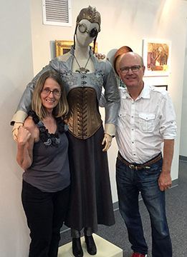

Located in Windsor, Connecticut, the Windsor Art Center is a nonprofit organization that promotes the visual and performing arts and presents visual art exhibits showcasing the works of a variety of artists working in diverse media and genres and hailing from throughout New England and beyond. Artist “talks” and children’s activities complete the annual programming. There is no charge to visit the gallery or the on-site gift shop which features locally made art. Parking is free and easily accessible. For more information on scheduled programs and exhibits, membership, and performing or exhibiting in the gallery, visit [www.windsorartcenter.org](http://www.windsorartcenter.org).