**Windsor Art Center Hosts *Soulful Journeys* – Connecticut Fiber Arts Collective**

Windsor, CT – The Windsor Art Center hosts *Soulful Journeys,* an exhibition featuring the work of the Connecticut Fiber Arts Collective (CtFAC), from March 12 through April 23, 2016. The collective is a diverse group of artists who share a common passion, creating art from fiber. Organized in 2011, the founding members of CtFAC sought an informal network of committed fiber artists to support and provide one another with inspiration and instruction. Their vision continues to focus on mutual goals of artistic growth and development, while sharing art with the public.

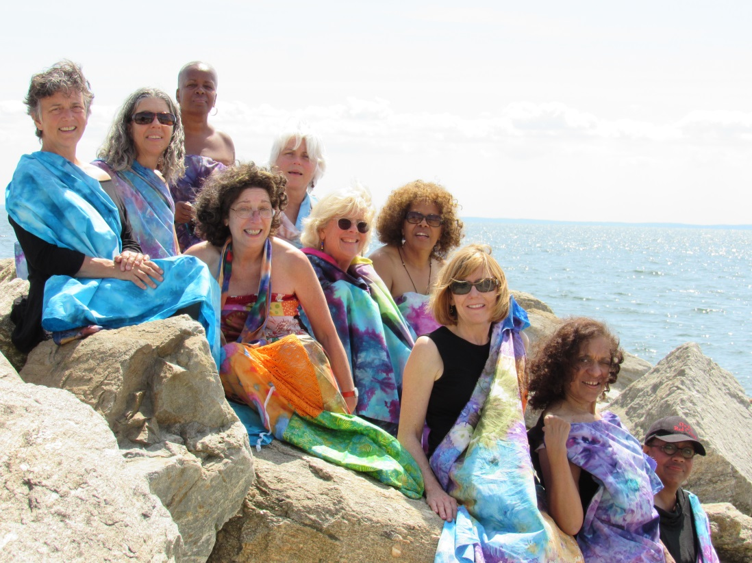The artistry of their work invites viewers to rethink the traditional concept of the quilt, expanding it from its original utilitarian origins and reimagining it as art. Original designs are created using a variety of techniques, including hand dyeing, felting, quilting, and appliqué, and then enhanced with embellishments such as beading, hand embroidery, and knitting.

For the Windsor Art Center show, *Soulful Journeys*, the CT Fiber Arts Collective took its inspiration from the nearby Connecticut River, with its suggestion of journeys, not only of the body, but of the spirit.

Fiber artists represented in the exhibition include Christina Blais, Diane L. Cadrain, Carol R. Eaton, Mary Lachman, Karen Loprete, Linda Martin, Wanda N. Seldon, Rosalind Spann, Antonia Torres, and Carol Vinick.

**The exhibit opens with a reception on Saturday, March 12, 2016, 5-7 pm**. As special programming included with the exhibit, the collective will offer two workshops and an artist talk.

**Workshop: *The Art of Fabric Collage* Saturday, March 19, 10 am-12 noon** Create original 8”X10” fabric art pieces through instruction on the use of value, color, and design. **Workshop fee:** $30; **Materials fee:** $5. RSVP at 860-688-2528. Please RSVP to 860-688-2528.

**Artist Talk: Saturday, April 9, 1-2 pm**  Meet several of the exhibiting fiber artists and hear how their work reflects their own life journeys. **Free.**

**Workshop: *Felted Labyrinth* Saturday, April 16, 10 am-12 noon** Create a felted finger labyrinth, an effective meditation tool - both in creation and use, through instruction on the technique of needle felting with wool roving. **Workshop fee**: $30; **Materials fee**: $10. RSVP at 860-688-2528.

Gallery hours for the Windsor Art Center are: Thursday, 6:00 to 8:00 pm; Saturday, 10:00 am to 4:00 pm; and Sunday, 11:00 am to 4:00 pm.

This exhibit is supported in part through sponsorship from Cigna and support from Vantis Life. For more information, please call 860.688.2528 or visit [www.windsorartcenter.org](http://www.windsorartcenter.org).